#OpColombia and the Architecture of Electoral Disinformation: A Comprehensive Analysis of the 2026 Colombian Presidential Elections

Executive Summary
The second round of the Colombian presidential elections, held on June 21, 2026, represents a critical, defining juncture in the nation's democratic trajectory. The electoral contest is characterized not only by acute ideological polarization but also by unprecedented, technologically sophisticated challenges to the fundamental integrity of the electoral apparatus. The runoff between the left-wing candidate Iván Cepeda, representing the Pacto Histórico coalition, and the ultra-right candidate Abelardo de la Espriella, leading the Defensores de la Patria movement, has unfolded against a highly volatile backdrop of systemic disinformation, coordinated cyber-activism, and profound institutional scrutiny. A central and highly disruptive catalyst in this volatile information environment has been a viral social media campaign operating under the revitalized banner of "#OpColombia," which heavily amplified claims of structural fraud. The apex of this campaign is centered around specific audiovisual artifacts, most notably a widely circulated video alleging that a high-ranking official from the Colombian National Registry of Civil State (Registraduría Nacional del Estado Civil) has definitively "broken the silence" regarding severe, systemic electoral irregularities engineered to alter the outcome of the presidential vote.
This comprehensive research report provides an exhaustive, multi-dimensional analysis of the 2026 Colombian electoral landscape, triggered by the specific phenomenon of the #OpColombia whistleblower claims. The investigation deconstructs the alarming convergence of evolved hacktivist operations, the increasingly scrutinized privatization of highly sensitive electoral logistics, the systemic and weaponized deployment of artificial intelligence (AI) in cognitive warfare, and the complex structural realities of the Colombian physical voting and tabulation process. The subsequent analysis reveals a profound institutional paradox. On one hand, the technical, legal, and administrative architecture of the Colombian electoral system has demonstrated robust empirical resilience, a fact validated by extensive domestic analysis and international observation missions from the European Union and the Organization of American States. On the other hand, the psychological, perceptual, and informational environment surrounding the electorate has been severely degraded by a sustained, multi-actor campaign deliberately designed to preemptively delegitimize the state institutions responsible for ensuring a peaceful democratic transition.
This document explores the mechanics of this cognitive warfare, fact-checks the specific claims of algorithmic and manual fraud, investigates the structural vulnerabilities stemming from corporate logistical monopolies, and analyzes the demographic disenfranchisement that structurally impacts the vote.

The Geopolitical, Ideological, and Domestic Landscape of the 2026 Runoff
To understand the efficacy and penetration of the #OpColombia disinformation campaign, it is strictly necessary to contextualize the extreme ideological polarization that defined the June 21, 2026, presidential runoff. The ballot presented the Colombian electorate with a stark, uncompromising divergence in national vision, policy formulation, and statecraft.
Iván Cepeda, a veteran senator and a foundational figure within the Pacto Histórico, represented the continuity, evolution, and intended consolidation of the progressive socio-economic reforms initiated by the outgoing Gustavo Petro administration. Cepeda's platform emphasized structural agrarian reform, the deepening of the complex "Total Peace" negotiation frameworks with various armed actors, and expansive social welfare architecture. His strategic selection of Aida Quilcué, a highly respected Indigenous leader, as his vice-presidential running mate served to firmly underscore the Pacto Histórico's ideological alignment with historically marginalized demographic sectors and territorial peripheries.
Conversely, the emergence of Abelardo de la Espriella represented a formidable consolidation of the Colombian hard-right. A prominent penal lawyer, businessman, and highly visible media personality, De la Espriella mobilized a potent populist base under the absolute promise of uncompromising state security, economic deregulation, and the total dismantling of progressive state structures. His rhetoric was deliberately combative and exceptionally polarizing; he famously established his political stance by declaring to progressive factions, “Gentlemen of the left, in me you will have an acrimonious enemy who will do everything possible to eviscerate and confront you”. This uncompromising posture resonated strongly with sectors of the electorate deeply disillusioned by the perceived security vacuums and economic turbulence of the preceding four years.
However, this profound ideological polarization did not merely confine itself to traditional policy debates or conventional electoral mobilization. It rapidly weaponized the administrative mechanics and the foundational trust of the election itself. Strikingly, outgoing President Gustavo Petro, despite commanding the executive branch and having been elected in 2022 under the exact same institutional and legal framework, actively fueled domestic narratives of potential electoral vulnerability. In the critical hours preceding the second round, Petro utilized his massive social media presence to point explicitly to the supposed mutability and vulnerability of the physical "E-14" tally forms, urging the citizenry to mobilize aggressively as "digital witnesses" to protect the vote from internal institutional sabotage.
The rhetoric emanating from the head of state provided immensely fertile ground for both domestic disinformation networks and international cyber-actors. When the executive branch itself publicly casts doubt on the integrity of the National Registry and the National Electoral Council (CNE), it inadvertently validates the conspiratorial narratives propagated by anonymous hacktivists and partisan operatives. In this hyper-sensitized environment, any technical glitch, localized logistical failure, or fabricated deepfake is immediately interpreted not as an administrative error, but as incontrovertible proof of a systemic, state-level conspiracy.

The Evolution of #OpColombia: From Infrastructure Denial to Cognitive Warfare
The hashtag "#OpColombia," currently attached to viral videos alleging systemic electoral fraud, is not a novel phenomenon within the Colombian digital and political sphere. Its utilization in 2026 represents a highly sophisticated evolution of a brand originally deployed during a distinctly different era of civil unrest. A genealogical analysis of the threat actor landscape is crucial for understanding the current nature of the electoral interference.
The origins of #OpColombia trace back to the widespread socio-political upheaval of May 2021, a period characterized by massive national strikes and intense domestic protests against the administration of then-President Iván Duque. During this volatile window, the decentralized, global hacktivist collective known as Anonymous initiated a coordinated digital offensive against the physical and digital infrastructure of the Colombian state, claiming to act in defense of human rights and protesting alleged police brutality. During the 2021 operations, Anonymous utilized traditional crowd-sourced bandwidth aggregation and rudimentary, publicly available distributed denial-of-service (DDoS) instruments, most notably the Low Orbit Ion Cannon (LOIC). Through these brute-force methods, the collective successfully disrupted access to mission-critical, public-facing portals belonging to the Colombian Senate, the Presidency of the Republic, and the National Army.
Forensic cybersecurity analysis of these early #OpColombia incursions suggests that the efficacy of the attacks relied heavily upon the exploitation of unpatched vulnerabilities within legacy government software architectures. Analytical reports from the period indicated that approximately 81% of hacktivist attacks globally were directly correlated with the presence of vulnerable, outdated software on the targeted websites. Furthermore, analysis of the DDoS traffic revealed that while Anonymous leveraged the ideological support of thousands of volunteers using LOIC, up to 90% of the actual malicious traffic volume was generated by a small number of highly concentrated, commercially available botnets.
By the time of the 2026 presidential runoff, the nature of these cyber threats had undergone a profound metamorphosis, reflecting a global shift in digital threat paradigms. The boundary separating ideologically driven, non-profit hacktivism from highly sophisticated, financially or geopolitically motivated cybercrime syndicates has blurred to the point of functional irrelevance. Threat intelligence research indicates a prevailing global trend where former hacktivist collectives—such as the groups identified as FunkSec, KillSec, and GhostSec—have actively transitioned into Ransomware-as-a-Service (RaaS) operations or complex disinformation brokers. This transformation is driven by ideological fatigue, the massive financial incentives of digital extortion, and, crucially, the widespread democratization of artificial intelligence. Modern hybrid threat actors now routinely utilize advanced generative AI models not only to write complex, evasive malware source code (such as the FunkLocker encryptor), but also to generate highly persuasive, hyper-realistic disinformation artifacts.

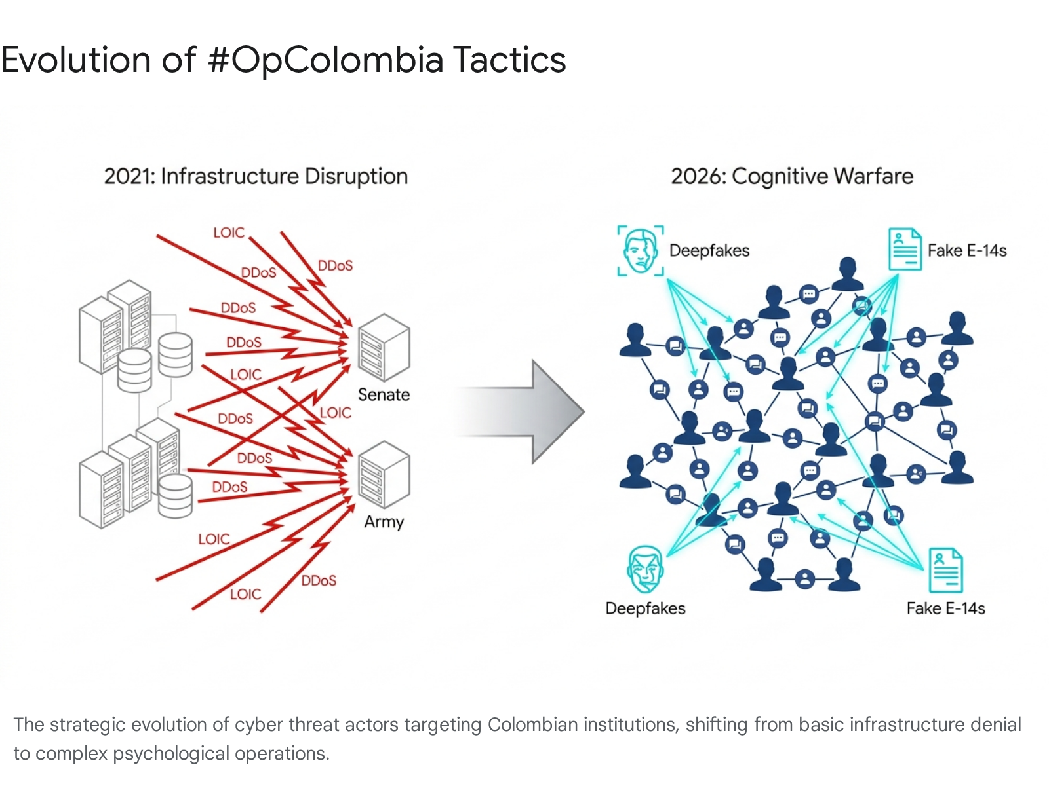In the specific context of the 2026 Colombian elections, #OpColombia pivoted definitively from brute-force infrastructure attacks to high-impact cognitive warfare and psychological operations (PsyOps). The infrastructure of the National Registry was not disabled via DDoS; rather, the perception of the Registry's integrity was attacked via social engineering and algorithmic amplification. The viral dissemination of the YouTube video titled "An official from the Colombian National Registry breaks the silence and denounces serious irregularities" perfectly encapsulates this strategic evolution. Instead of expending vast computational resources attempting to breach hardened, heavily audited electoral servers to alter a mathematical outcome, the threat actors simply injected highly emotive, conspiratorial, and synthetically generated content into the hyper-polarized digital ecosystem just hours before the physical polls opened. The strategic objective is preemptive delegitimization: to ensure that a statistically significant proportion of the electorate fundamentally rejects the certified electoral results, thereby plunging the state into a crisis of governance, regardless of the actual, verified mathematical outcome of the ballot boxes.

Algorithmic Disinformation and the Anatomy of the "Fraud" Narrative
The two-month campaign window immediately preceding the June 2026 runoff witnessed the complete normalization of artificial intelligence as a primary, accessible tool for political destabilization and cognitive manipulation. The European Union Electoral Observation Mission (MOE UE), in its preliminary declarations, explicitly and emphatically noted that AI had become a commonplace instrument utilized to synthesize highly convincing fake images, counterfeit audio recordings, and manipulated videos aimed at discrediting both the leading presidential candidates and the foundational integrity of the electoral authorities themselves.
A rigorous, systematic forensic analysis of the specific digital claims amplifying the #OpColombia hashtag reveals a highly structured, remarkably agile disinformation architecture. Independent fact-checking organizations and journalistic consortia within Colombia, most notably ColombiaCheck and the political analysis portal La Silla Vacía, dedicated immense resources to systematically dismantling the core pillars of the prevailing fraud narrative. Their investigations exposed a sophisticated blend of AI manipulation, the deliberate decontextualization of standard administrative procedures, and outright, verifiable fabrication.

Typology of Deception: Deconstructing Specific Electoral Claims
The digital disinformation campaign that saturated the Colombian electorate operated across multiple, distinct attack vectors, each precision-targeted at different vulnerabilities within the complex administrative aspects of the electoral process.

1. The "Whistleblower" Phenomenon and Institutional Impersonation
The most potent weapon in the cognitive warfare arsenal was the generation of counterfeit internal dissent. Videos and audio clips circulating virally on platforms like YouTube and X (formerly Twitter) purportedly featured high-ranking officials spontaneously denouncing massive, systemic fraud. In one highly prominent and damaging instance, an AI-generated audio file flawlessly cloned the voice of National Registrar Hernán Penagos. The synthetic audio depicted Penagos openly admitting to the illegal injection of votes and orchestrating a massive cover-up of electoral fraud in favor of specific candidates. Forensic audio analysis and immediate pushback from the Registry confirmed the audio was entirely synthetically generated; no such admission ever occurred. However, the psychological damage of deepfakes relies on speed; by the time the fact-check is published and verified, the synthetic audio has already achieved millions of impressions, permanently embedding the narrative of institutional corruption into the minds of susceptible voters.

2. The Fabrication of Census Manipulation
A persistent, mathematically impossible narrative—which was alarmingly echoed and inadvertently amplified by President Gustavo Petro's own rhetoric regarding software vulnerabilities—suggested an anomalous, highly illegal inflation of the national electoral census. Viral posts claimed that the proprietary transmission software utilized by the Registry had maliciously injected 885,000 fraudulent voter IDs into the electoral rolls to pad the margins for a specific outcome. Rigorous technical audits and journalistic fact-checks confirmed this to be a fundamental technological impossibility: the software program in question operates strictly as a one-way conduit to transmit preliminary vote counts to central servers; it possesses zero read/write access to the heavily encrypted, frozen demographic database of the electoral census. Furthermore, the census itself was frozen and physically audited long before the software was deployed. Related viral videos exacerbated xenophobic tensions by falsely associating a normal, previously flagged administrative increase in voter registration with the illegal mass transit of foreign migrants across border zones, a claim completely debunked by the geographical distribution of the new registrations.

3. The "Contagion" of the E-14 Form
The "E-14" form is the foundational, physical document where polling station juries (ordinary citizens drafted for the day) manually record the final vote tallies at their specific table. Because it is filled out by hand under immense pressure at the end of a long day, it is naturally prone to human error, corrections, and cross-outs (known locally as "tachones"). This human element makes the E-14 the perfect vector for disinformation. Coordinated accounts circulated hundreds of images of E-14 forms featuring severe cross-outs, claiming, for instance, that Abelardo de la Espriella had received 528 votes at a specific table, but the numbers were violently scribbled out to hide the theft.
When fact-checkers located the original, official Registry documents corresponding to those specific table numbers, they proved these viral images were either highly manipulated digital montages (the actual, verified count was 22 votes, not 528) or they were deliberate, bad-faith misinterpretations of legitimate human errors. In instances where juries made a mistake, they clearly annotated the correction in a separate, legally binding document known as the "Acta de Claveros." The disinformation actors simply cropped out the legal correction to present the raw mistake as evidence of a massive, coordinated conspiracy to steal the election.

4. Procedural Misrepresentation and Decontextualization
A final, highly effective vector involved taking standard, legally mandated technical instructions and reframing them maliciously. For example, the Registry's official, long-standing instruction to polling juries to leave boxes without votes entirely blank (rather than writing a zero, which can be easily altered into an eight or a nine) was reframed in viral parodies and angry explanatory videos as a deliberate, sinister mechanism designed specifically to facilitate the later insertion of fake results by corrupt officials. Normal administrative procedures were thus criminalized in the court of public opinion.
Disinformation Vector | Core Claim Propagated | Method of Deception | Verified Institutional Reality | Source
Audio Deepfake | National Registrar Hernán Penagos admits on tape to vote injection and systemic fraud. | AI Voice Cloning / Synthetic Media | Audio is synthetically generated; no such admission ever occurred.
Census Inflation | Election software illicitly injected 885,000 illegal ID cards into the voter roll. | Technical Misattribution / Fabrication | Transmission software lacks access to alter census data; the census was audited and frozen.
E-14 Alteration | Photos show forms with massive cross-outs, hiding hundreds of stolen votes. | Digital Montage / Decontextualization | Images were digitally altered; legitimate human errors were properly documented and legally corrected in scrutiny acts.
Border Voting | Spikes in ID registrations are linked to illegal foreign migrants crossing the border to vote. | Decontextualization / Xenophobic Framing | Registration spikes were statistically normal, not concentrated on borders, and involved Colombian nationals.
The rapid, unchecked proliferation of these fabricated artifacts—which were primarily responsible for driving the trending #OpColombia discourse—demonstrates a highly sophisticated, data-driven understanding of the Colombian electorate's historical traumas and psychological vulnerabilities. By specifically targeting the E-14 forms and the demographic integrity of the census, malicious actors attack the precise administrative nodes where unpredictable human interaction interfaces with opaque data processing. In doing so, they exploit the natural, inevitable complexities of manually counting over twenty million pieces of paper to construct an impenetrable, self-sustaining narrative of a systemic, state-sponsored conspiracy.

The Privatization of Logistics and the Architecture of Institutional Suspicion
While the preceding analysis demonstrates that the vast majority of the specific fraud claims amplified by #OpColombia rely entirely on fabricated evidence and digital manipulation, it is intellectually dishonest to dismiss the public's suspicion as pure paranoia. The underlying administrative and institutional architecture of the Colombian elections possesses genuine, profound structural vulnerabilities that make such disinformation highly plausible to the average citizen.
The core vulnerability lies in the deep, opaque, and highly lucrative reliance of the National Registry on a small cartel of private, multinational conglomerates for the execution of the most sensitive aspects of electoral logistics and software management. The Colombian electoral logistical ecosystem is largely dominated by a few deeply entrenched corporate players, most notably the Spanish technology firm Indra, the vast domestic consortium Thomas Greg & Sons, and the Colombian data management and IT firm Grupo ASD. The intimate involvement of these private, profit-driven entities—particularly in the design, administration, and execution of the proprietary software utilized for both the preliminary vote count and the official consolidation of data—has drawn persistent, fierce scrutiny from political actors across the entire ideological spectrum. This scrutiny has been validated by former magistrates of the National Electoral Council, who have publicly questioned the extent to which the sovereign state has outsourced its most critical democratic function to private interests.

The Grupo ASD Controversy: Sovereign Risk and the Precedent of Failure
The most severe, structurally damaging critique of the 2026 logistical arrangement centers entirely on the continued participation of Grupo ASD (Asesoría en Sistematización de Datos). Historically, Grupo ASD has managed highly lucrative, incredibly sensitive contracts for the National Registry. Their portfolio includes the provision of the core software computing architecture for vote accounting, the administration of vast databases, and the deployment of technological solutions for the realization of the official scrutiny across all territorial orders during the highly contested presidential elections of 2014, 2018, and 2022.
However, the company's recent international track record casts an extraordinarily long, dark shadow over the integrity of the 2026 Colombian process. In late 2025, Grupo ASD successfully bid to operate the Preliminary Electoral Results Transmission System (TREP) for the highly volatile presidential elections in neighboring Honduras. The Honduran elections subsequently descended into total administrative chaos and political crisis. The leading opposition candidate, Salvador Nasralla, explicitly and publicly accused the "corrupt ASD company" of catastrophic technical failures that directly facilitated electoral theft. Nasralla's campaign documented massive, unexplained data blackouts, arbitrary restrictions placed on independent technical observers, and, most alarmingly, unauthorized reboots of the central electronic system conducted without any multi-party veeduría (oversight) during the critical hours of vote transmission.
The fallout from the Honduran disaster was so severe, and the loss of public faith so absolute, that the Honduran Congress immediately initiated sweeping legislative reforms explicitly designed to permanently ban the contracting of any foreign enterprise in future vote-counting processes. Grupo ASD was forced to retreat from the country under a massive cloud of institutional disgrace and immense political pressure.
The geopolitical implication for the Colombian elections occurring just months later is profound and deeply concerning. Exceptional investigative journalism conducted by the independent outlet Revista RAYA revealed a staggering lack of institutional accountability regarding ASD's domestic operations. RAYA established that despite the catastrophic, highly publicized failure in Honduras, Grupo ASD maintained deep operational continuity within the Colombian electoral apparatus. Following the Honduran scandal, ASD quietly requested to cede its formal participation in the "Unión Temporal Integración Logística Electoral 2026" (the consortium awarded the contract for the 2026 Colombian elections).
However, this formal withdrawal appears to have been largely cosmetic. Subsequent investigations by RAYA established that ASD personnel continued operating in the shadows. Testimonies and logistical records proved that ASD staff were actively conducting software simulations, maintaining the core plant of contracted technical personnel, and exercising logistical control over the very scrutiny software that would be used to count the votes, just fifteen days prior to the critical Colombian legislative elections that preceded the presidential runoff. Attempts by political actors to silence these investigations were unsuccessful; notably, a Bogota judge denied a request by the outlet La Silla Vacía to force Revista RAYA to retract certain investigative claims regarding overlapping PR strategies and electoral manipulation networks, further emboldening the public's right to question the logistical opacity.
The continued, opaque reliance of the Colombian state on a private contractor that had fundamentally compromised the democratic transition in a neighboring Latin American republic creates an inherent, massive vulnerability. It provides a highly credible, fact-based foundation upon which domestic political actors and foreign cyber-operatives can easily build their elaborate narratives of total illegitimacy. When a sovereign state actively delegates the most sacred function of its democracy—the consolidation and certification of the citizen's vote—to private entities operating with such a questionable track record and lack of transparency, it inevitably and predictably invites the precise "architecture of suspicion" that fuels destructive cognitive operations like #OpColombia. The fact that the Registry allowed ASD to maintain back-end access after a catastrophic international failure renders the official assurances of security hollow to a skeptical public.

Scrutiny, Software, and Institutional Safeguards: The Mechanics of Verification
To accurately assess the genuine resilience of the Colombian electoral system against both the avalanche of AI-generated disinformation and the legitimate concerns regarding privatized software, one must dissect the fundamental bifurcation of the Colombian vote-counting process. The system operates on two distinct, parallel tracks: the "preconteo" (pre-count) and the "escrutinio" (official scrutiny). The conflation of these two processes by the public is the primary vector through which panic is sown.
The preconteo is an entirely informative, rapid-response mechanism. It is designed solely to deliver preliminary, unverified results to the public and the media on the night of the election, satisfying the psychological need for immediate outcomes. Crucially, the preconteo possesses absolutely zero legal validity. It relies heavily on the rapid, telephone-based transmission of data from the polling stations to central hubs, and it is here that the controversial software from companies like Indra and ASD is primarily utilized.
The binding, legally definitive, and official results of the Colombian presidential election are generated exclusively through the escrutinio. This definitive process is emphatically not a software calculation. It relies entirely on the painstaking, manual verification of the physical paper tally sheets (the original E-14s and the subsequent acts of claveros). This physical verification is conducted by independent judges of the Republic and designated public notaries, operating in public coliseums under the direct, aggressive, and continuous supervision of highly trained legal teams representing all participating political campaigns.
The proprietary software systems—which are the primary, obsessive target of the #OpColombia narratives and political suspicion—do not dictate or calculate the final legal result; their role in the escrutinio is strictly limited to compiling and publishing the manually transcribed, legally verified data onto a central dashboard.
To counter the massive wave of disinformation regarding hidden algorithms and altered results, the National Registry enacted unprecedented transparency measures during the 2026 cycle. Within mere hours of the physical polls closing, high-resolution, unedited digital scans of every single E-14 form from across the entire nation were published simultaneously on the Registry's open-access website. This radical open-source approach completely democratized the audit process. It allowed political campaigns, non-governmental transparency organizations, and individual citizens sitting in their homes to mathematically verify the aggregated national figures against the primary, handwritten source documents. This transparency protocol severely and demonstrably neutralized the long-term impact of the fabricated, photoshopped E-14 images that had circulated so widely on social media prior to the election.
Furthermore, while the Registry adamantly refused to open-source the entirety of the software code to the general public—citing severe, valid cybersecurity concerns that publishing the architecture would provide a roadmap for state-sponsored hackers to compromise the integrity of the results system—they did implement a critical compromise. In an unprecedented move, the Registry allowed authorized technical auditors from all political parties privileged, unrestricted access to a four-week-long, detailed exposition and review of the source codes for the specific programs utilized in the consolidation process. Prior to the opening of the polls, the entire technological infrastructure underwent multiple, exhaustive technical stress tests, full-load simulations replicating national voting volume, and a comprehensive international audit to identify vulnerabilities.

The Verdict of International Observation and Statistical Verification
The empirical, verifiable reality of the Colombian electoral system stands in stark, diametric contrast to the apocalyptic narratives of total algorithmic control propagated by #OpColombia. The technical consistency, resilience, and fundamental fairness of the process have been repeatedly and unequivocally validated by the world's premier international observation bodies.
The Electoral Observation Mission of the European Union (MOE UE) deployed a massive contingent of 143 specialized observers drawn from 27 different nations, establishing a physical presence across 591 distinct polling locations throughout the republic. Concurrently, the Organization of American States (OAS) deployed a highly specialized technical mission consisting of 96 experts from 24 countries, monitoring the process across 26 of Colombia's departments. Both international organizations, following rigorous methodologies, unequivocally endorsed the fundamental integrity of the elections. The head of the EU mission famously summarized the operation by declaring, "Once again, Colombia has given a lesson in democracy," directly repudiating the narratives of a stolen election.
Following the intense controversies and allegations of "missing votes" in previous electoral rounds, independent, highly sophisticated statistical analysis was conducted by the domestic Electoral Observation Mission (MOE). Their analysts specifically targeted the behavior of polling stations that reported exactly zero votes for specific major candidates—a phenomenon frequently cited by conspiracy theorists as mathematical proof of algorithmic erasure. The MOE's exhaustive analysis of the data definitively confirmed that the behavior of these zero-vote tables was statistically normal, entirely expected, and perfectly consistent with historical, localized voting patterns; there was no evidence of a centralized algorithmic anomaly.
Most decisively, when the complex, manual, and legally binding escrutinio conducted by the independent judicial branch was finally concluded weeks later, the results yielded a staggering 99.94% coincidence rate with the highly contested, software-driven, rapid preconteo published on election night. Furthermore, a legal challenge brought before the Tribunal of Cundinamarca demanding a highly disruptive special recount, a physical reopening of the E-14 forms, and a forensic digital audit of the pre-count software was procedurally admitted, but the Tribunal firmly denied the request for provisional measures that would have halted the certification process.
This mathematical reality—a 99.94% match between the software approximation and the manual judicial count—effectively and permanently dismantles the systemic software fraud hypotheses pushed by both domestic political actors and international cyber-collectives. The system, despite its highly problematic reliance on controversial private contractors like Grupo ASD, contains sufficient manual redundancies, physical paper trails, and aggressive public transparency protocols to prevent the unchecked, digital manipulation of the final democratic outcome.

Demographics, the Census, and the Architecture of Structural Disenfranchisement
Beyond the sophisticated cyber threats and the intense debates over proprietary software, the physical, demographic mechanics of the 2026 election present a highly complex reality. It is a landscape characterized by relatively robust administrative procedures operating paradoxically alongside severe structural disenfranchisement and the localized failure of state capacity.
The definitive electoral census authorized for the 2026 presidential elections comprises a total of 41,421,973 eligible citizens, encompassing voters residing both within the national territory and the vast Colombian diaspora abroad. This figure represents a slight, expected demographic increase from previous legislative cycles, mirroring the natural population growth of the nation. In a necessary administrative action prior to the legal closure of the census, the National Registry undertook a massive, rigorous data-purging process. Utilizing cross-referenced civil databases, the Registry successfully identified and permanently removed 47,604 outdated registrations belonging to citizens who were confirmed to be deceased. This vital data hygiene measure was explicitly praised by the EU observation mission as a necessary step adhering tightly to international best practices for electoral integrity, ensuring that "ghost voters" could not be exploited.
### The Youth Disenfranchisement Paradox
However, the legal framework governing the administration of the Colombian census contains a severe, anachronistic structural flaw that systematically disenfranchises a highly specific, politically volatile demographic cohort. Under current Colombian electoral law, the administrative window for the registration of citizens entering the electoral census for the very first time is legally mandated to be completely suspended exactly four months prior to the date of any national election.
The European Union Electoral Observation Mission, in its preliminary report, highlighted the devastating democratic impact of this rigid legal timeline. Because of this arbitrary four-month suspension, any Colombian citizen who happens to celebrate their 18th birthday—the legal age of enfranchisement—during that specific four-month window leading up to election day is completely and legally deprived of their constitutional right to vote in that specific election.
Statistical analysis of the 2026 demographic data reveals that this structural exclusion resulted in the explicit, legal disenfranchisement of a staggering 172,278 young citizens who possessed the fundamental right to vote but were barred from the ballot box entirely due to administrative rigidity.

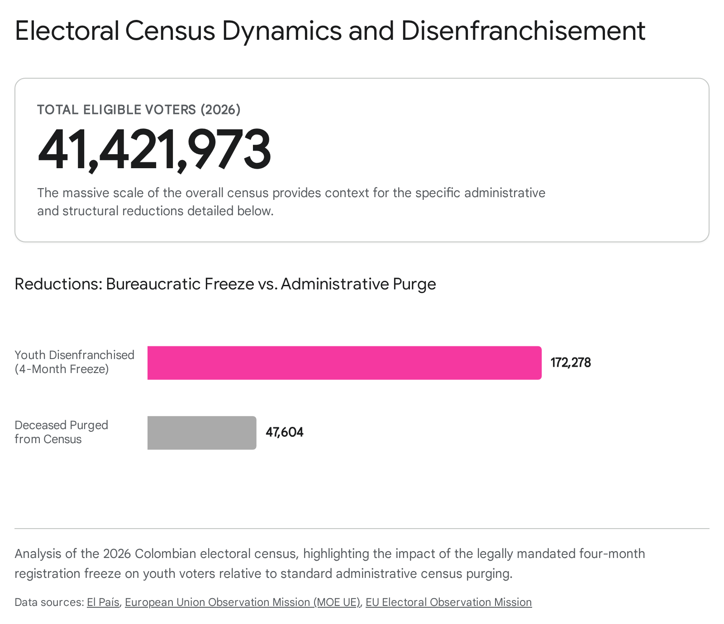This structural exclusion is further compounded by severe, localized operational failures that directly impacted young voters on election day. On the morning of the June 21 runoff, widespread reports emerged from major urban centers, notably the Galerías sector in the capital city of Bogotá, regarding massive logistical failures affecting first-time voters. Citizens who had successfully navigated the bureaucracy and registered their newly issued national identification cards prior to the strict March 31 deadline reported arriving at their officially assigned polling stations only to be informed by the juries that their identification numbers simply did not appear in the physical registry books printed for that location.
While independent observers generally agree that these incidents are indicative of localized administrative incompetence rather than centralized, systemic fraud, the psychological impact is devastating. These failures disproportionately affect the youngest, most politically energized, and historically marginalized first-time voters. The resulting frustration exacerbates deep-seated youth disillusionment with the democratic state and provides immediate, highly emotional, anecdotal fuel for the broader, more malicious delegitimization narratives pushed by operations like #OpColombia.

Real-Time Election Day Dynamics: Corporate Coercion and the URIEL Apparatus
Despite the highly charged digital atmosphere, the physical election day operations on June 21 proceeded under conditions of tense, heavily militarized peace. The integrity of the physical vote was heavily monitored by a vast array of state apparatuses, coordinated primarily through the Ministry of the Interior. The central node for this massive surveillance effort is the Unit for Immediate Reception for Electoral Transparency (URIEL). URIEL acts as the primary, real-time clearinghouse for receiving, processing, and assigning formal citizen complaints regarding alleged irregularities and severe electoral crimes.
The sheer volume of citizen engagement with this oversight body reflects the intense anxiety surrounding the process. By the mid-afternoon of the runoff election, URIEL officials reported that they had registered and processed over 2,600 formal, actionable complaints regarding alleged electoral crimes across the national territory.
However, amidst the standard reports of illegal campaigning near voting centers or isolated instances of vote-buying, a highly concerning and structurally insidious vector of electoral irregularity emerged: widespread "constreñimiento al voto" (voter coercion) executed aggressively within the formal corporate sector.
The Minister of Labor, Antonio Sanguino, held an emergency press conference on election day to confirm that his entity had received 65 formal, heavily documented complaints regarding severe labor coercion and had immediately opened active administrative investigations into every single case. These complaints detailed a systematic pattern of behavior where corporate executives, middle managers, and business owners were overtly leveraging their hierarchical, economic power over their employees. Workers were being explicitly pressured, threatened with termination, or aggressively incentivized to vote for a specific right-wing candidate in the presidential contest.
According to the Ministry's initial findings, this economic coercion was not isolated to a specific region but was reported uniformly across the national territory, occurring within both massive multinational conglomerates and smaller domestic enterprises. In response to this grave violation of democratic autonomy, the Ministry of Labor expedited the issuance of 10 immediate preventative measures and a national circular warning employers of severe administrative sanctions. Furthermore, the Ministry compulsed official copies of the evidence directly to the Attorney General's Office (Fiscalía General de la Nación), the National Electoral Council, and the Registraduría, demanding the immediate initiation of criminal prosecutions for the felony of electoral constraint.
The explosion of corporate coercion highlights a critical evolution in electoral interference. As the digital sphere becomes heavily monitored by fact-checkers, and as the physical vote-counting software is subjected to exhaustive international audits, undemocratic actors operating within the elite strata of society are reverting to raw, unmitigated economic leverage to artificially engineer the electoral outcome. This form of coercion completely circumvents sophisticated cyber-defenses and algorithmic transparency measures, striking directly at the fundamental autonomy, economic security, and physical survival of the individual working-class voter.

Strategic Synthesis and Conclusions
The 2026 Colombian presidential election represents a definitive paradigm shift in the fundamental nature of electoral risk, not just within Colombia, but across the entirety of Latin America. The traditional, historically dominant vectors of democratic interference—such as physical ballot stuffing, the violent intimidation of rural voters by armed actors, and the blatant logistical manipulation of the final tally—have been heavily superseded by the terrifying efficiency of the architecture of cognitive warfare.
The explosive resurgence of the #OpColombia hashtag, driven by the viral dissemination of an AI-cloned Registraduría official supposedly "breaking the silence," demonstrates unequivocally that modern threat actors have evolved. They possess a profound understanding that in a hyper-connected, deeply polarized society, manipulating the psychological perception of the electoral apparatus is vastly more efficient, far cheaper, and ultimately more destructive to the fabric of the state than attempting to physically hack the heavily guarded mathematical apparatus itself. The goal is no longer to subtly alter the vote count to steal an election; the goal is to ensure that a massive, radicalized portion of the electorate fundamentally rejects the mathematically verified results, thereby paralyzing the incoming administration and shattering the mandate to govern.
Based on the exhaustive analysis of the technological, logistical, and demographic data surrounding the June 21 runoff, this report concludes the following critical insights regarding the state of Colombian electoral integrity:
- The Absolute Supremacy of Cognitive Warfare: The widespread, highly effective deployment of Artificial Intelligence to generate synthetic audio and manipulated imagery designed specifically to simulate institutional whistleblowing represents a severe, potentially uncontrollable escalation in electoral interference. The speed at which algorithmic disinformation travels through platforms like X and YouTube far outpaces the institutional capacity for forensic fact-checking. By the time a deepfake is scientifically debunked by the Registry or independent journalists, the psychological damage to the electorate's baseline trust has already metastasized.
- The Strategic Liability of Privatized Infrastructure: The Colombian National Registry's continued, opaque reliance on multinational corporate entities with compromised international reputations creates an unnecessary and profound strategic vulnerability for the state. Specifically, the continued involvement of Grupo ASD in Colombian logistics, immediately following their catastrophic, highly publicized failures managing the electoral software in Honduras, provides a legitimate, fact-based foundation for public panic. While the manual redundancies of the claveros protect the final physical vote count, the opacity of these corporate contracts provides a continuous, inexhaustible supply of legitimate suspicion that domestic political actors and foreign threat actors readily and eagerly weaponize. The state cannot outsource its sovereign democratic functions to discredited corporations without sacrificing the trust of its citizens.
- Institutional Resilience Contradicted by Demographic Exclusion: The purely administrative and mathematical framework of the Colombian election is functionally robust. Achieving a 99.94% accuracy rate between the rapid software pre-count and the meticulous manual judicial scrutiny—a fact validated by the EU and OAS—is a monumental logistical achievement that effectively disproves the viral narratives of systemic algorithmic fraud. However, this technical triumph is severely undermined by the legal rigidity that systematically disenfranchises hundreds of thousands of youth voters due to the arbitrary four-month census freeze. This bureaucratic lockout alienates the precise demographic cohort that is most active, most volatile, and most influential in the digital spaces where anti-institutional narratives flourish, creating a dangerous feedback loop of disenfranchisement and radicalization.
- The Resurgence of Economic Coercion: The heavily documented rise in corporate voter coercion, resulting in dozens of federal investigations by the Ministry of Labor, indicates a strategic pivot by undemocratic actors. Recognizing the increasing difficulty of hacking the audited software or manipulating the physical ballots, powerful economic interests are reverting to raw, localized economic extortion to influence outcomes. This requires a completely different regulatory and prosecutorial response than cyber-defense.
Ultimately, the viral denouncements of "serious irregularities" amplified by the #OpColombia network are not indicative of actual, systemic software fraud. Rather, they are symptomatic of a much deeper, existential crisis of institutional trust within the Colombian state. The technical mechanics of the election held firm. However, defending future democratic transitions in Colombia will require the state to radically evolve its defensive posture. The government must not only harden its software architecture and decisively sever ties with compromised private logistics firms, but it must urgently develop proactive, real-time counter-disinformation architectures capable of dismantling algorithmic falsehoods before they permanently corrupt the psychology of the electorate.

Works cited
1. Elecciones Colombia 2026, en vivo | Iván Cepeda, tras votar en Bogotá: “Cuando triunfemos, vamos a gobernar para todo el país y no para un sector”, https://elpais.com/america-colombia/elecciones-presidenciales/2026-06-21/elecciones-colombia-2026-la-segunda-vuelta-de-las-presidenciales.html 2. De la Espriella surge como duro rival para el progresista Cepeda prometiendo mano dura en Colombia | The Associated Press, https://www.ap.org/news-highlights/en-foco/2026/de-la-espriella-surge-como-duro-rival-para-el-progresista-cepeda-prometiendo-mano-dura-en-colombia/ 3. PRELIMINARY STATEMENT - EEAS, https://www.eeas.europa.eu/sites/default/files/2026/documents/Declaracio%CC%81n%20Preliminar%20primera%20vuelta%20MOE%20UE%20Colombia%202026_0.pdf 4. Compare las propuestas de los candidatos para las elecciones de Colombia 2026, https://elpais.com/america-colombia/elecciones-presidenciales/2026-06-21/compare-las-propuestas-de-los-candidatos-para-las-elecciones-de-colombia-2026.html 5. Abelardo de la Espriella: “Si el Gobierno desconoce el orden, el Ejército debe intervenir para restaurarlo”, https://elpais.com/america-colombia/elecciones-presidenciales/2026-06-21/abelardo-de-la-espriella-si-el-gobierno-desconoce-el-orden-el-ejercito-debe-intervenir-para-restaurarlo.html 6. El registrador nacional, Alexander Vega, entregó su opinión respecto a la jornada electoral 🗳️ - YouTube, https://www.youtube.com/watch?v=gsOlR4RyOvk 7. ¿Contradicción? Petro pone en duda a la Registraduría, la misma entidad que certificó su victoria - YouTube, https://www.youtube.com/watch?v=Jr5BxwjobGo 8. GRAN DESPLIEGUE DE OBSERVACIÓN ELECTORAL EN LAS ELECCIONES DE COLOMBIA - EVoting, https://evoting.com/2026/06/11/observacion-electoral-en-colombia/ 9. Registraduría se pronuncia tras afirmaciones del presidente Gustavo Petro sobre formularios E-14, https://www.noticiascaracol.com/politica/elecciones-colombia/registraduria-se-pronuncia-tras-afirmaciones-del-presidente-gustavo-petro-sobre-formularios-e-14-rg10 10. Tribunal de Cundinamarca admitió tutela por presuntas irregularidades en elecciones presidenciales del 31 de mayo, pero negó medidas provisionales, https://www.infobae.com/colombia/2026/06/19/tribunal-de-cundinamarca-admitio-tutela-por-presuntas-irregularidades-en-elecciones-presidenciales-del-31-de-mayo-pero-nego-medidas-provisionales/ 11. “Ojo con el 2026”: las narrativas desinformantes contra las elecciones - YouTube, https://www.youtube.com/watch?v=_Am8iSJ5NW0 12. Hacker group Anonymous leaks Colombia's police and army files amid protest crackdown, https://advox.globalvoices.org/2021/05/24/hacker-group-anonymous-leaks-colombias-police-and-army-files-amid-protest-crackdown/ 13. Anonymous hackeó la página del Ejército de Colombia - Doble Llave, https://doblellave.com/anonymous-hackeo-la-pagina-del-ejercito-de-colombia/ 14. Hacker Intelligence Initiative, Monthly Trend Report #12 - Imperva, https://www.imperva.com/docs/HII_Denial_of_Service_Attacks-Trends_Techniques_and_Technologies.pdf 15. The Cybercrime situation in Spain - INFINITY, https://h2020-infinity.eu/sites/default/files/2023-08/INFINITY%20-%20The%20Cybercrime%20situation%20in%20Spain.pdf 16. From Ideology to Financial Gain: Exploring the Convergence from Hacktivism to Cybercrime, https://www.rapid7.com/blog/post/2025/06/03/from-ideology-to-financial-gain-exploring-the-convergence-from-hacktivism-to-cybercrime/ 17. OEA, https://www.oas.org/fpdb/press/2026_MOE_Colombia_Elecciones_Presidenciales_Segundo_Informe_ESP.pdf 18. Registraduría - ColombiaCheck, https://colombiacheck.com/tags/registraduria 19. | ColombiaCheck, https://colombiacheck.com/node 20. MOE presentó análisis técnico en el que aclara inquietudes sobre el ..., https://moe.org.co/moe-presento-analisis-tecnico-en-el-que-aclara-inquietudes-sobre-el-proceso-electoral/ 21. Video en redes sociales mostraría masivo fraude en la segunda ..., https://www.infobae.com/colombia/2026/06/16/registraduria-rechazo-acusaciones-de-manipulacion-de-tarjetones-y-reforzo-vigilancia/ 22. ¿Fraude en el escrutinio? Exmagistrado denuncia aumento irregular de 800 mil personas | 6AM W, https://www.youtube.com/watch?v=yt4cYNIBqc8 23. EXCLUSIVO: ASD sigue participando en organización de ..., https://revistaraya.com/exclusivo-asd-sigue-participando-en-organizacion-de-elecciones-2026-a-pesar-de-que-renuncio-al-contrato.html 24. Empresa que contará votos en Honduras fue denunciada por manipulación, https://www.expedientepublico.org/empresa-que-contara-votos-en-honduras-fue-denunciada-por-manipulacion/ 25. Empresa colombiana señalada de fraude en Honduras será decisiva en las elecciones colombianas en 2026 - Revista RAYA, https://revistaraya.com/empresa-colombiana-senalada-de-fraude-en-honduras-sera-decisiva-en-las-elecciones-colombianas-en-2026.html 26. Las cuatro empresas privadas que controlarán las elecciones presidenciales del 31 de mayo - Revista RAYA, https://revistaraya.com/las-cuatro-empresas-privadas-que-controlaran-las-elecciones-presidenciales-del-31-de-mayo.html 27. Bitacora-III.-Solucion-integral - MOE, https://moe.org.co/wp-content/uploads/2026/01/Bitacora-III.-Solucion-integral.pdf 28. DECLARACIÓN PRELIMINAR - EEAS, https://www.eeas.europa.eu/sites/default/files/2026/documents/Declaracio%CC%81n%20Preliminar%20Legislativas%20MOE%20UE%20Colombia%20ES%202026MOE%20UE.pdf 29. Alertas ciudadanas en la jornada electoral: denuncias sobre irregularidades en elecciones presidenciales - RTVC Noticias, https://www.rtvcnoticias.com/politica/denuncias-sobre-irregularidades-en-elecciones-presidenciales-de-2026 30. Unidad de Recepción Inmediata para la Transparencia Electoral - Ministerio del Interior, https://www.mininterior.gov.co/unidad-de-recepcion-inmediata-para-la-transparencia-electoral/ 31. Mininterior ha recibido más de 2.000 denuncias por presuntas irregularidades en elecciones, https://www.noticiascaracol.com/politica/elecciones-colombia/mininterior-ha-recibido-mas-de-2-000-denuncias-por-presuntas-irregularidades-en-elecciones-rg10 32. Elecciones Colombia 2026 | De la Espriella lanza una amenaza contra el Congreso: “Si traicionan el mandato ciudadano, se encontrarán con el Gobierno” - EL PAÍS, https://elpais.com/america-colombia/elecciones-presidenciales/2026-06-20/elecciones-colombia-2026-la-segunda-vuelta-de-las-presidenciales.html

