28.08.2024
Ozone
1 . JHEMCU Smoke Stopper XT30 XT60 Male Female 1-6S Self-Resetting Resettable Fuse Smoke Test Tool - 661 rub.
2. Printed breadboard 4 x 6 cm double-sided for soldering, 5 pieces – 333 rubles
3. Spool of CR-PETG plastic for 3D printer CREALITY 1.75 Black ( black ) 2 pcs (1 kg each) – 3648 rub.
SmartBuy LE 64 GB Class 10 black memory card 10 pcs. for 699 rubles – 6990 rubles
5. UPS / Uninterruptible power supply SVEN UP-L800 with USB and built-in voltage stabilizer 400W - 5775r
6. DEFENDER Network filter 5 sockets with grounding, 3 meters, switch, black 5 pcs. for 537r - 2685r
7. Screwdriver HEX2 Wera 354 Hex -Plus for internal hexagon, 2 x 75 mm, WE-023105 2 pcs. for 776r – 1552r
8. Set of colored heat shrink tubes, 400 pcs , 8 sizes. Heat shrink for wires and cables. 2 pcs for 310 rubles - 620 rubles
9. Electric kettle BQ KT1834G White-silver / Glass / 1.7 l 2200 W – 1729 RUR
10. Adhesive tape stationery 48 mm x 66 m, 6 pcs. (set) 2 sets of 465 rubles - 930 rubles
11. Transparent protective glasses (2 pcs. in a package) (set) – 380 RUR
12. Propellers for drone 8 inches Gemfan Cinelifter 8040-3, 2 pairs, propellers for quadcopter 2 pairs for 686r – 1372r
13. Propellers for FPV drone 5 inches 51366 Hurricane MCK v3 Gemfan , 4 pairs (set) 2 sets of 623r - 1246r
14. Masking tape Alliance masking tape, 48mm*50m, 3 pcs. (set) 5 sets for 617r – 3085r
15. Power connector XT30U power connector ( Amass ), plug + socket (M + F, set, 5 pairs) (set) 4 sets of 430r - 1720r
16. Set of silicone wires 0.35 mm sq. 22AWG/10 m (6 colors) – 2403 rub.
17. Set of silicone wires 0.75 mm sq. 18AWG/4 m (6 colors) – 2403 RUR
18. Connector XT-60 10 pieces set) 5 pieces for 499 – 2495r
19. Flux - TT indicator gel, 20 ml. 2 pcs for 197r – 394r
LiitoKala Battery Charger Lii M4S Li- ion , Li-Fe, Ni-CD (26650/18650/14500) 4 Slots 5pcs for 1609r – 8045r
21. Carbon Fiber Frame for FPV Quadcopter MyPads Mark 4 V2 8-inch Carbon Fiber 367mm – 4222r
22. PCB cleaner SOLINS FLUX-OFF effective remover of soldering flux, oil, bitumen, grease, wax, anti- bitumen / Flux-off solvent , aerosol 400 ml - 659 RUR
23. Power connector XT30U (M+F) (male + female connector) 5 pairs ( Amass ) (set) – 490 RUR
24. Current limiter JHEMCU Smoke Stopper (XT60, XT30) 2 pcs. for 749r – 1498r
25. Set of silicone wires 0.08 mm sq. 28AWG/15 m (6 colors) - 1902 rub.
26. Antenna 5.8 GHz 3Dbi right polarization 150 mm. RHCP SMA for FPV drone 13 pcs at 1205r – 15665r
27. Carbon frame MANTA10 Lite, 10 inches (402 mm) for FPV drones – 7612 rub.
28. SMA adapter 2 pcs. (F-female - SMA-male) 2 pcs. for 384r - 768r
29. Cable for connecting peripheral devices, gold, silver 2 pcs. for 468r - 936r
30. Metal nozzle/attachment for Creality K1/K1 Max 2 pcs. for 860r – 1720r
31. Printed breadboard 4 x 6 cm double-sided for soldering, 5 pieces (set) 4 sets of 333r - 1332r
32. Multifunctional stripper 2 pcs. for 569r – 1138r
33. Unibob electrical tape Electrical insulating adhesive tape PVC, increased thickness, black 15 mm *20 m 130 microns 3 pcs. for 140 rubles - 420 rubles
34. Isopropanol – 1974r
Total Ozone: 88802r
Aliexpress
1. Radio frequency signal amplifier SPF5189 SPF5189Z SPF-5189Z, 50-4000 MHz, NF = 0.6 dB, with shielding 10 pcs for 182 rubles + shipping 607 rubles - 2427 rubles
2. Mark4 Mark 4 5 inches 225 mm/6 inches 260 mm/7 inches 295 mm/8 inches 375 mm/10 inches 473 mm FPV 9 pcs. for 1635 rubles – 14715 rubles
3. Original Team BlackSheep TBS Crossfire Lite CRSF TX 915/868 MHz Long Range Radio System Radio Controlled – 15094r
4. Gemfan 7037 7" Durable 3-Blade Polycarbonate Propeller/Reinforced High Speed Black 5mm Diameter Propeller for Cinelifter Accessories MacroQuad 2pcs for 383r + shipping 373r – 1139r
5. ToolkitRC M6D 500W 15A DC Dual Channel Mini Smart Charger Discharger for 1-6S Lipo Battery FPV Model Spare Part M8 3pcs at 5388r + shipping 1407 - 17571r
Total Aliexpress : 50946r
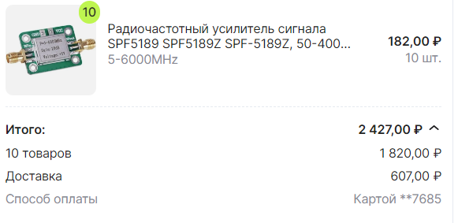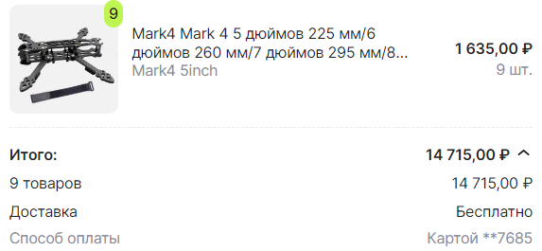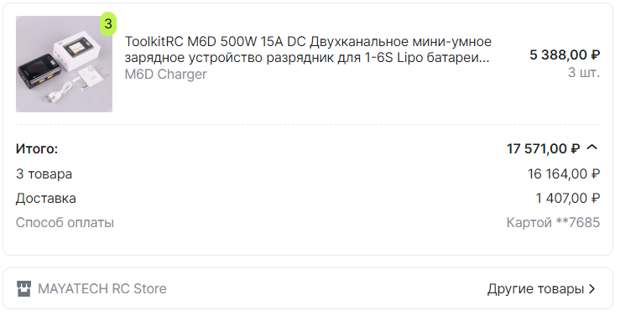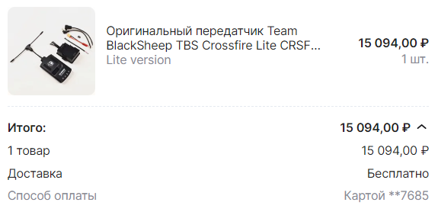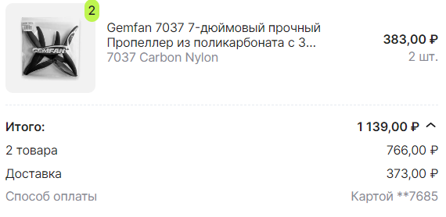
Wildberries
- Braided copper tape for removing solder with flux 2 pcs. 350 RUR – 700 RUR
- Table lamp with clamp and mount 2 pcs. 562r - 1124r
- Set of soft bamboo toothbrushes 4 pcs. – 231 RUR
- Chips filter for cleaning soldering tips 2 pcs. for 255r – 510r
- Screw M3X12 for hexagon, stainless steel 100 pcs (set) – 263 RUR
- F5220 Hexagon head screw M3x9mm, 8 pcs. (set) – 265 RUR
Total Wildberries : 3093r

Yandex Market
- Power connectors 6 pcs. three-pin Amass 3 MR60-M and 3 MR60-F. Mr 60 - set 6 pcs. 3 sets for 615r – 1855r
- Battery Li- ion 4500 mAh 3.6V JSC "Energia" INR21700 36pcs for 319 RUR - 11494 RUR
Total Yandex: 13349r
09/01/2024
China Cargo
- 1 Stack SKYSTARS F405 50A 13 pcs from 5811 p – 75543 p
- Receiver 915 MHz 13 pcs at 1942r – 25246r
- Video transmitter AKK FX2 Dominator 5.8GHz Long range (power 2000mW) 8pcs at 4943r – 39544r
- Motor XING 52pcs for 2100r – 109200r
- CADDX camera Ratel 2 13pcs for 2250r – 29250r
- TBS receiver 2 pcs. for 4490r – 8980r
- 8 inch motor 2 pcs 5510r – 11020r
- Motor 10 inches 8 pcs 3265r – 26120r
- External module ERLS 10 pcs at 6280r – 62800r
- SKYZON glasses 8 pcs. for 38380r – 307040r
- AKB 6 S LiPO 1800 5 pcs at 5778r – 28890r
- AKB 2 S LiPO 3000 8 pcs at 2782r – 22256r
- Remote control Radiomaster TX 12 10pcs for 9844r – 98440r

Total cargo China: 844329r

02.09.2024
China cargo
- AKB 6 S LiPO 2200 10 pcs for 5300 rub – 53000 rub
- AKB 6 S LiPO 5500 5 pcs for 8560r – 42800r
- AKB 4 S LiPO 1500 4 pcs for 2200 rub – 8800 rub

Total cargo China: 104600r

All tools for the company
- PAX Shelf MS-254 2284800 2 pcs. for 5195r – 10390r
- Makita Set 34pcs, D-36980 – 2307 RUR
- Makita Cordless drill/driver . G-series 18V, 13mm, 42/24Nm (2x1.5Ah, charger) DF488DWE – 12905r
- Gigant Rack STFR 2000x1000x500 mm, 4 shelves, collapsible stand ( gray ) G-STFR-1054-2.0 2 pcs. for 5199r – 10398r
Total for all tools: 36,000 RUR
05.09.2024
Aliexpress
- Gemfan Flash 1050 3-Blad 10*5*3 PC Three Blade Propeller FPV Mark4 V2 10 Inch Frame RC Multi-Rotors Long Range Drones DIY Parts 2 Sets $2160 – $4320
Total Aliexpress : 4320r
Total purchase: 1,145,439r

